Omnitags Expansion Group
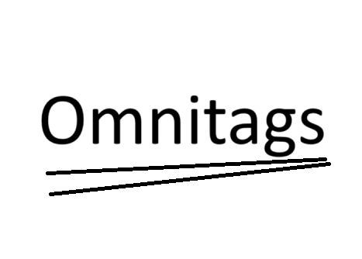

Members:
- Khenjy Johnelson (Leader)

This group will dedicate themselves into applying the concepts of Omnitags into all kinds of frameworks from web to desktop to mobile development. Using a method that comes from my github repository using codeigniter 3. I hope this group will succeed in achieving such target.

Github link: https://github.com/khenjyjohnelson/hotelhebat

How Omnitags works
Using a Postman Environment JSON Reading method, this technique focuses on the retrieval of table keys and values from the JSON file into the framework, thus making MVC possible in a matter of minutes. Now the things that isn’t complete yet are the application into multiple possible frameworks that could support those mechanics.

How likely it’s possible
It’s pretty hard to assume that every framework is possible to apply this since it required a lot of customized codes.

How many debug that it can reduce
It can reduce a lot of debugging like typo management, since everything is connected anyway.

Why do you want to reduce typo management?
Because sometimes it takes a lot of developer’s time to find the error.

What’s the result
The fully customized app with predictable scenario and less typo debug that needs to be checked. More like wordpress, but for actual developers.

